**CCNA – 200 – 301**

(Lab # 2b)

**VLAN Configuration (With Trunk)**

**Objective:**

* Creating two virtual LANs named **VLAN 10 and VLAN 20**.
* Network IP is 192.168.1.0 and all PCs are configured with IP address in range (192.168.1.1 to 192.168.1.8).
* Configuring switchports of both switches for VLAN 10 & VLAN 20 in access mode.
* For switch (SW0) and switch (SW1), the ports **f0/1** and **f0/2** are configured to be accessed in **VLAN 10**, while the ports **f0/3** and **f0/4** are configured to be accessed in **VLAN 20** and the port **f0/5** will be configured as trunk.
* Showing the results by pinging between the devices in both VLANs.

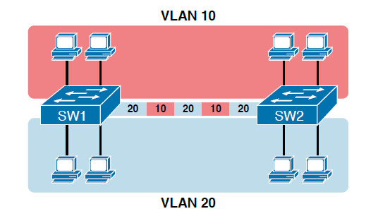

**Logical Topology in Packet Tracer**

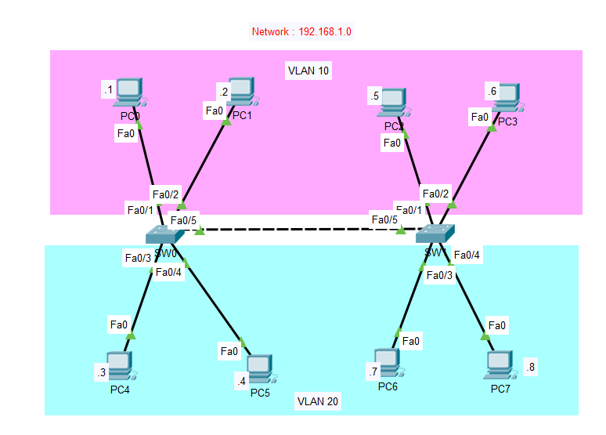

Configuring Switch (SW0) for VLAN 10 & 20 & Trunking

SW0>enable

SW0#configure terminal

SW0(config)#interface range fastEthernet 0/1-2

SW0(config-if-range)#switchport mode access

SW0(config-if-range)#switchport access vlan 10

SW0(config-if-range)#exit

SW0(config)#interface range fastEthernet 0/3-4

SW0(config-if-range)#switchport mode access

SW0(config-if-range)#switchport access vlan 20

SW0(config-if-range)#exit

SW0(config)#interface fastEthernet 0/5

SW0(config-if)#switchport mode trunk

SW0(config-if)#exit

SW0(config)#do show vlan

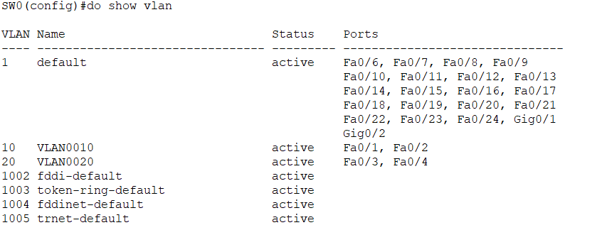

Configuring Switch (SW1) for VLAN 10 & 20 & Trunking

SW1>enable

SW1#configure terminal

SW1(config)#interface range fastEthernet 0/1-2

SW1(config-if-range)#switchport mode access

SW1(config-if-range)#switchport access vlan 10

SW1(config-if-range)#exit

SW1(config)#interface range fastEthernet 0/3-4

SW1(config-if-range)#switchport mode access

SW1(config-if-range)#switchport access vlan 20

SW1(config-if-range)#exit

SW1(config)#interface fastEthernet 0/5

SW1(config-if)#switchport mode trunk

SW1(config-if)#exit

SW1(config)#do show vlan

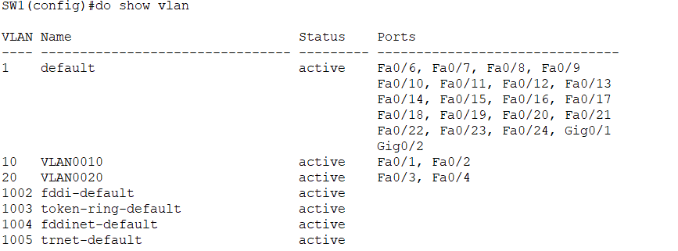

*Pinging from PC0 (VLAN10) to PC0 (VLAN10): Successful*

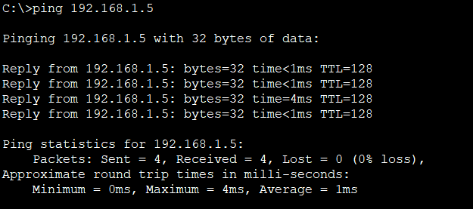

*Pinging from PC0 (****VLAN10****) to PC0 (****VLAN20****): Unsuccessful*

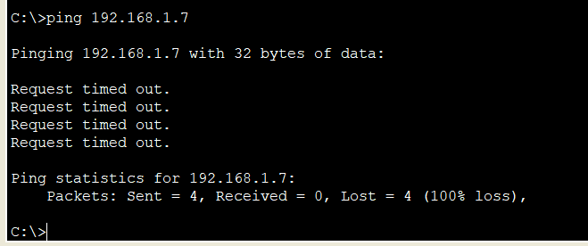

*Pinging from PC4 (****VLAN20****) to PC7 (****VLAN20****): Successful*

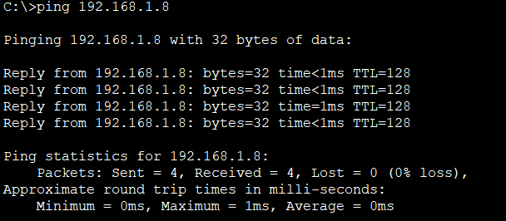

*Pinging from PC7 (****VLAN20****) to PC0 (****VLAN10****): Unsuccessful*

